# **Laboratory practice No. X: Complete the title of the laboratory practice**

|  |  |
| --- | --- |
| **Julian David Ramirez Lopera**  Universidad Eafit  Medellín, Colombia  jdramirezl@eafit.edu.co | **Andres Salazar Galeano**  Universidad Eafit  Medellín, Colombia  asalaza5@eafit.edu.co |

**3) Practice for final project defense presentation**

**3.2) If edges are represented with adjacency lists instead of adjacency matrices, memory consumption decreases dramatically, as it goes from O(v^2) to O(e). Where v is the number of vertices in the graph and e the number of edges in the graph. It is possible to have a greater amount edges than that of vertices (e < v), nonetheless, v^2 is generally way bigger than the number of edges.**

**3.4) O(v + e)**

**3.5) v stands for the number of vertices in the graph, and e stands for the number of edges in the graph. This algorithmic complexity comes from the fact that each vertex and edge is checked and explored once.**

***4) Practice for midterms***

* 1. *1) self.dfs(i+rowNbr[k], j + colNbr[k], visited)*
  2. Matrix:

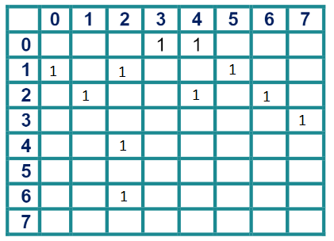

List:

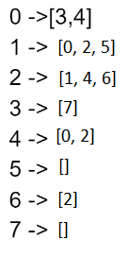

* 1. *A) O(n)*
  2. *1) ii 2) i*
  3. *1) Falso 2) Verdadero*